LAPORAN PRAKTIKUM

SISTEM KEAMANAN DATA

# PRAKTIKUM IV

**VIGENERE CIPHER**



## Disusun oleh :

Eggar Aliya Dewangga (V3923022)

## Dosen

Yusuf Fadila Rachman. S.Kom., M.Kom

# PS D-III TEKNIK INFORMATIKA SEKOLAH VOKASI UNIVERSITAS SEBELAS MARET 2024

## Hasil Dan Pembahasan

## 

## Coding

1. def generate_key(text, key):
2. key = list(key)
3. if len(text) == len(key):
4. return key
5. else:
6. for i in range(len(text) - len(key)):
7. key.append(key[i % len(key)])
8. return "".join(key)
9. def vigenere_encrypt(text, key):
10. encrypted_text = []
11. key = generate_key(text, key)
12. for i in range(len(text)):
13. if text[i].isalpha():  # Mengabaikan selain huruf
14. shift = (ord(text[i].upper()) + ord(key[i].upper())) % 26
15. encrypted_char = chr(shift + ord('A'))
16. encrypted_text.append(encrypted_char if text[i].isupper() else encrypted_char.lower())
17. else:
18. encrypted_text.append(text[i])
19. return "".join(encrypted_text)
20. def vigenere_decrypt(encrypted_text, key):
21. decrypted_text = []
22. key = generate_key(encrypted_text, key)
23. for i in range(len(encrypted_text)):
24. if encrypted_text[i].isalpha():  # Mengabaikan selain huruf
25. shift = (ord(encrypted_text[i].upper()) - ord(key[i].upper()) + 26) % 26
26. decrypted_char = chr(shift + ord('A'))
27. decrypted_text.append(decrypted_char if encrypted_text[i].isupper() else decrypted_char.lower())
28. else:
29. decrypted_text.append(encrypted_text[i])
30. return "".join(decrypted_text)
31. # Input manual
32. text = input("Masukkan teks: ")
33. key = input("Masukkan kunci: ")
34. # Proses enkripsi
35. encrypted_text = vigenere_encrypt(text, key)
36. print("Teks terenkripsi:", encrypted_text)
37. # Proses dekripsi
38. decrypted_text = vigenere_decrypt(encrypted_text, key)
39. print("Teks terdekripsi:", decrypted_text)

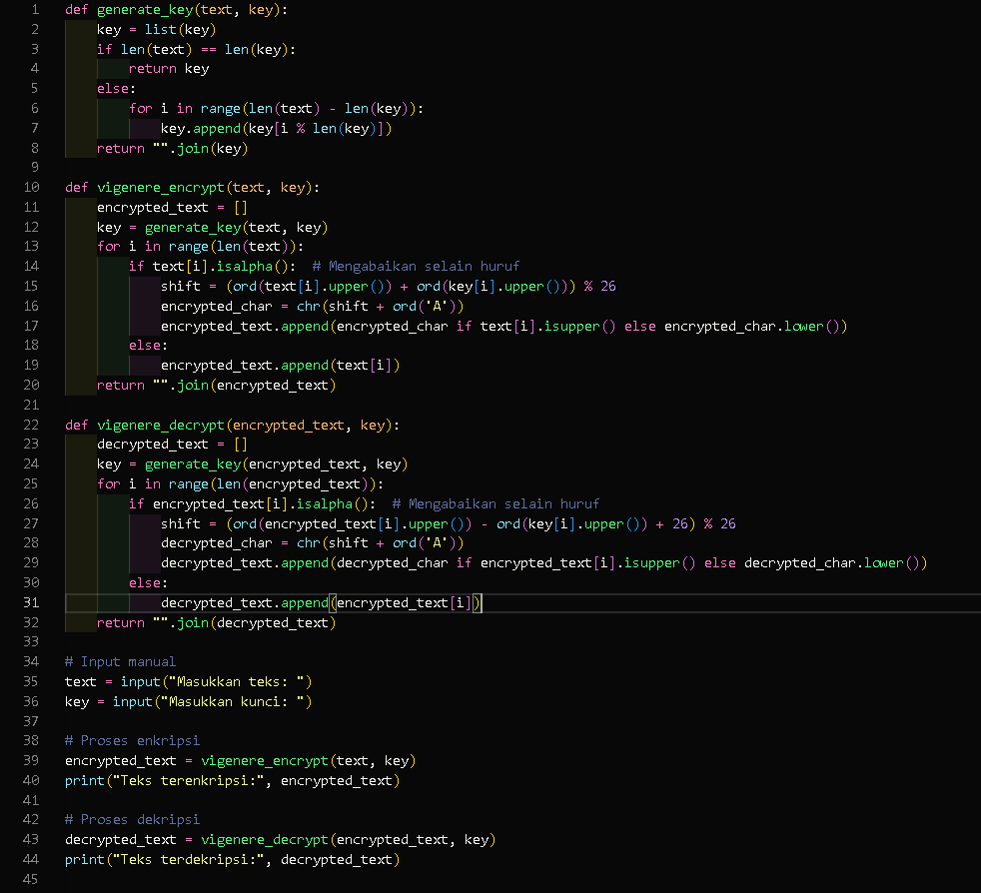

**C. Hasil**

